Acme Co
Industrial and office supply distribution

Annual Report
Fiscal Year 2025 · year ended 31 December 2025
FY2025 at a glance
Metric | FY2025 | FY2024 | Change
Revenue | $69.1M | $64.1M | +7.9%
Gross profit | $20.7M | $19.5M | +6.4%
Gross margin | 30.0% | 30.4% | −0.4 pts
Orders | 6,358 | 6,071 | +4.7%

In this report
— Letter to shareholders
— FY2025 financial review
— Category performance
— Customer and geographic performance
— Risk factors
— Outlook for FY2026

Head office: 2200 Industrial Parkway, Toronto, ON M9W 0A1, Canada
Gulf office: Office 1408, Harbour Tower, Dubai, United Arab Emirates
Prepared for Acme Co shareholders. All figures from the FY2025 fact sheet unless marked as computed.

1. Letter to shareholders
Dear fellow shareholders,
On behalf of the board and the management team, I am pleased to present Acme Co’s annual report for fiscal year 2025. Acme Co distributes industrial and office supplies to customers in Canada and the Gulf, operating from our head office in Toronto and our office in Dubai. FY2025 was a year of steady, well-balanced progress for the business.
The headline numbers: revenue reached $69.1 million, up 7.9% from $64.1 million in FY2024. Gross profit was $20.7 million, up 6.4% from $19.5 million, and gross margin finished at 30.0%, a 0.4-point decline from 30.4% in the prior year. We processed 6,358 orders, 4.7% more than the 6,071 orders of FY2024. Because revenue grew faster than order count, our average revenue per order rose from roughly $10,559 to roughly $10,875 (computed from revenue and order counts in the fact sheet), evidence that our customers are taking more responsibility for their supply needs from us.
By category, Material Handling remains the engine of the business at 56.0% of revenue, with Electrical contributing 17.6%. The eight remaining categories together account for 26.4% (computed). By customer, our base is healthy and diversified: our top 20 customers represent 13.65% of revenue, and no single customer exceeds 1.34%. By geography, Canada delivered 69.7% of revenue and the Gulf region 26.7% (computed), with the United States at 3.6%.
We are candid about our principal risk: a category mix in which a single line carries 56.0% of revenue. Our FY2026 priorities, set out in Section 6, are therefore built around broadening the category portfolio, deepening the Gulf, and defending a 30% gross margin. We are confident the foundations of FY2025 support the plan that follows, and we thank you for your continued confidence in Acme Co.
The Management of Acme Co
2200 Industrial Parkway, Toronto, ON M9W 0A1, Canada · Office 1408, Harbour Tower, Dubai, UAE

2. FY2025 financial review
Acme Co closed FY2025 with revenue of $69.1 million, an increase of 7.9% from $64.1 million in FY2024. Gross profit was $20.7 million, up 6.4% on the year, on gross margin of 30.0% — 0.4 points below the prior-year gross margin of 30.4%. Order volume grew 4.7%, from 6,071 to 6,358 orders. The table below summarises the year; the detailed monthly figures appear in the fact sheet.
Metric | FY2025 | FY2024 | Year over year
Revenue | $69.1M | $64.1M | +7.9%
Cost of goods sold | $48.4M | $44.6M | —
Gross profit | $20.7M | $19.5M | +6.4%
Gross margin | 30.0% | 30.4% | −0.4 pts
Orders | 6,358 | 6,071 | +4.7%

Monthly pattern
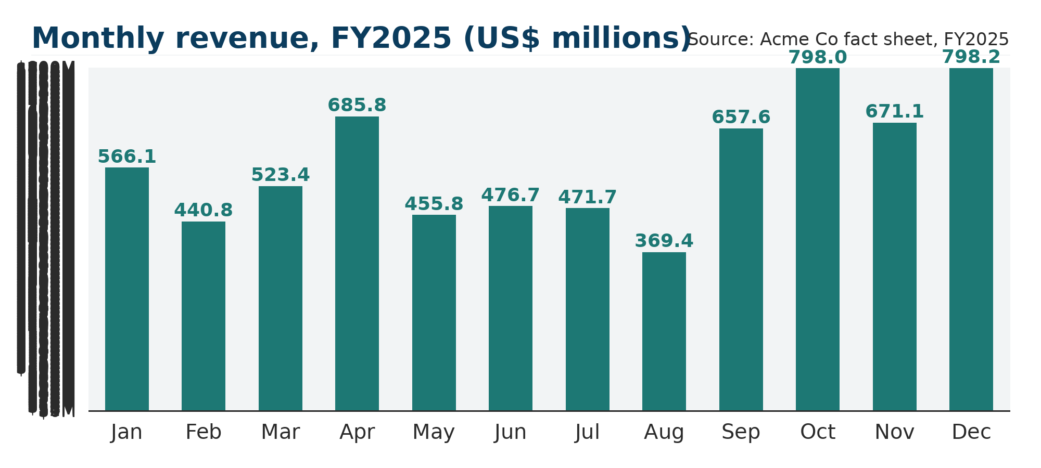
Figure 1 — Monthly revenue, FY2025 (US$ millions; computed from fact-sheet monthly detail).
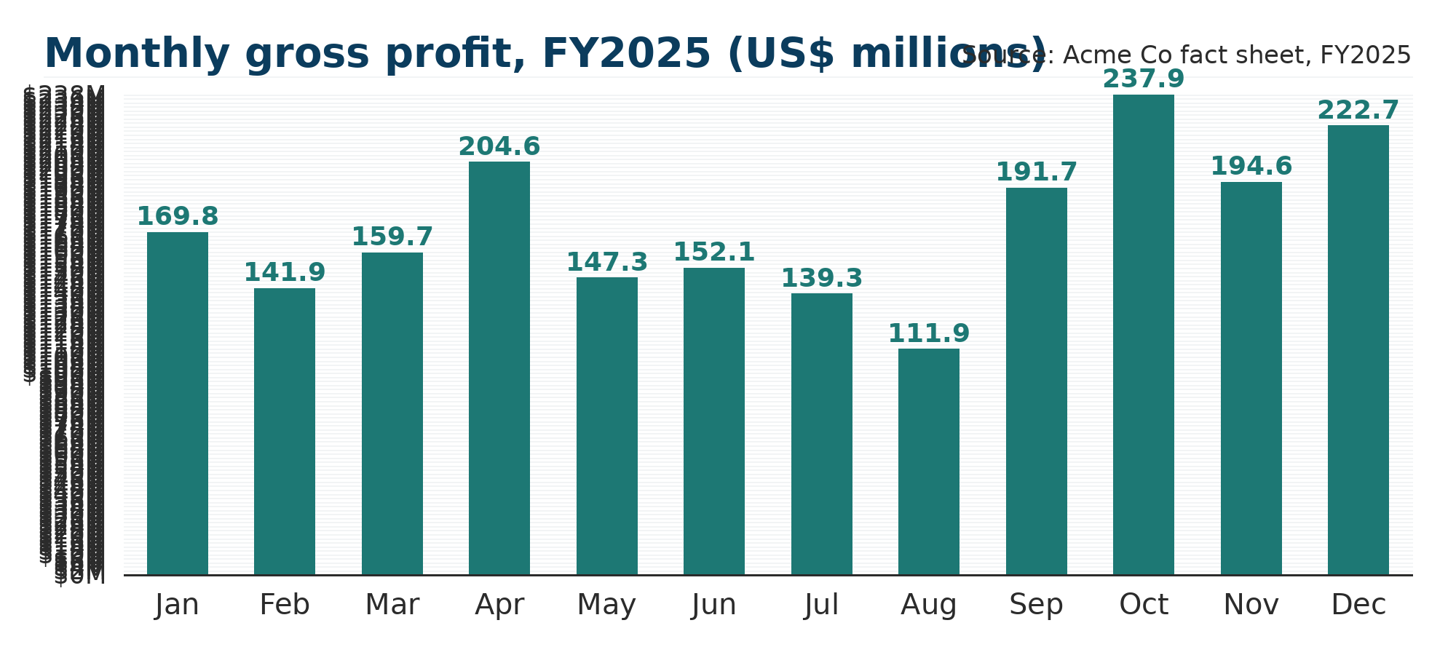
Figure 2 — Monthly gross profit, FY2025 (US$ millions; computed from fact-sheet monthly detail).
The year had a clear seasonality profile. Computed from the monthly detail, the fourth quarter was the strongest at $22.7 million (32.8% of full-year revenue, computed), with October and December the two peak months at roughly $8.0 million each. August was the softest month at $3.7 million. Monthly gross margin moved between approximately 28% and 32% across the twelve months (computed), settling at 30.0% for the full year.

Order economics
Order count rose 4.7% to 6,358, while revenue rose 7.9%. The resulting average revenue per order — computed from revenue divided by order count — increased from roughly $10,559 in FY2024 to roughly $10,875 in FY2025, a rise of about 3% (computed). Larger baskets per order supported revenue growth outpacing volume growth, and they will be a focus in FY2026 alongside volume.

3. Category performance
The largest category was Material Handling, which generated $38,734,228.05, or 56.0% of FY2025 revenue. Electrical was the second-largest category at $12,203,595.88, or 17.6% of revenue. Together the two largest categories represent 73.6% of the business (computed); the remaining eight categories contribute the other 26.4% (computed).
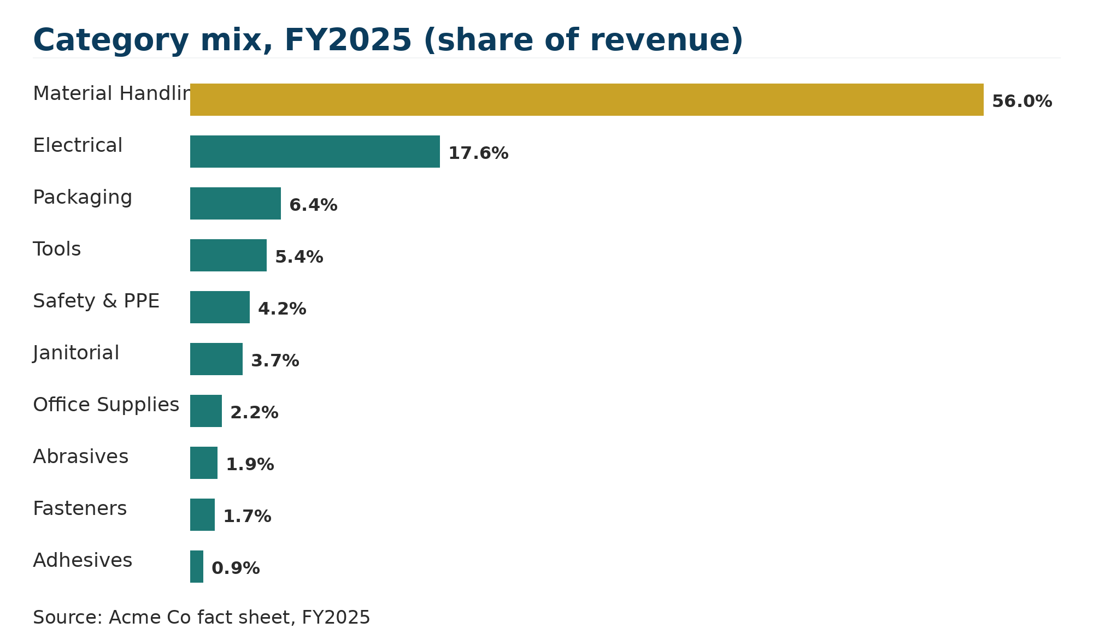
Figure 3 — Category mix, FY2025, share of revenue.
Category | FY2025 revenue | Share of revenue
Material Handling | $3873.42M | 56.0%
Electrical | $1220.36M | 17.6%
Packaging | $442.59M | 6.4%
Tools | $375.55M | 5.4%
Safety & PPE | $291.41M | 4.2%
Janitorial | $254.17M | 3.7%
Office Supplies | $151.30M | 2.2%
Abrasives | $131.00M | 1.9%
Fasteners | $114.79M | 1.7%
Adhesives | $60.04M | 0.9%
Total | $69.15M | 100.0%

Within the remainder of the portfolio, Packaging is the third-largest category at $4,425,870.55 (6.4%), followed by Tools at $3,755,547.27 (5.4%) and Safety & PPE at $2,914,085.72 (4.2%). The five smallest categories — Janitorial (3.7%), Office Supplies (2.2%), Abrasives (1.9%), Fasteners (1.7%) and Adhesives (0.9%) — are all sub-5% lines that, in aggregate (computed), represent 10.4% of revenue and form the natural bench for diversification in FY2026.

4. Customer and geographic performance

Customer base
The top 20 customers together account for 13.65% of FY2025 revenue. The largest single customer, Foxglove Stores LLC, represents 1.34%; the top five customers represent 5.18% and the top ten represent 8.71% (both computed from the shares in the table below). No customer relationship exceeds 1.34% of revenue, which we regard as a diversified and balanced customer base for a distribution business of this scale.
Rank | Customer | FY2025 revenue | Share of revenue
1 | Foxglove Stores LLC | $92.686M | 1.34%
2 | Pearl Developments Ltd. | $74.964M | 1.08%
3 | Granite Fabrication Ltd. | $70.434M | 1.02%
4 | Montcalm Entreposage inc. | $65.687M | 0.95%
5 | Falcon Retail Group LLC | $54.343M | 0.79%
6 | Érable Fleuve Entreposage Inc. | $53.614M | 0.78%
7 | Saint-Laurent Académie ltée | $50.467M | 0.73%
8 | Al Waha Property Management LLC | $49.629M | 0.72%
9 | Driftwood Distribution Ltd. | $46.124M | 0.67%
10 | Meridian Cedar Developments Ltd. | $43.360M | 0.63%
11 | Atlas Manufacturing Ltd. | $39.533M | 0.57%
12 | Meridian Industries Corp. | $36.849M | 0.53%
13 | Westbrook Logistics LLC | $35.479M | 0.51%
14 | Fleuve Santé ltée | $34.498M | 0.50%
15 | Érable Mauricie Collège Inc. | $33.975M | 0.49%
16 | Fleuve Beauport Logistique inc. | $33.288M | 0.48%
17 | Bluewater Distribution Ltd. | $33.188M | 0.48%
18 | Nimbus Distribution Corp. | $32.288M | 0.47%
19 | Evergreen Trading Ltd. | $31.942M | 0.46%
20 | Stonebridge Freight Ltd. | $31.445M | 0.45%
 | Top 20 customers (total) | $9.24M | 13.65%

Geographic performance
Canada is the anchor market at $48,209,042.23, or 69.7% of revenue on 4,474 orders. The United Arab Emirates is the second market at $11,726,342.95 (17.0%, 1,069 orders). The wider Gulf — Saudi Arabia (5.7%), Qatar (2.2%) and Oman (1.8%) — contributes 9.7% of revenue (computed), and the United States contributes 3.6%.
Market | FY2025 revenue | Share of revenue | Orders
Canada | $4820.90M | 69.7% | 4,474
United Arab Emirates | $1172.63M | 17.0% | 1,069
Saudi Arabia | $396.19M | 5.7% | 401
United States | $249.20M | 3.6% | 178
Qatar | $150.45M | 2.2% | 114
Oman | $125.27M | 1.8% | 122
Total | $69.15M | 100.0% | 6,358
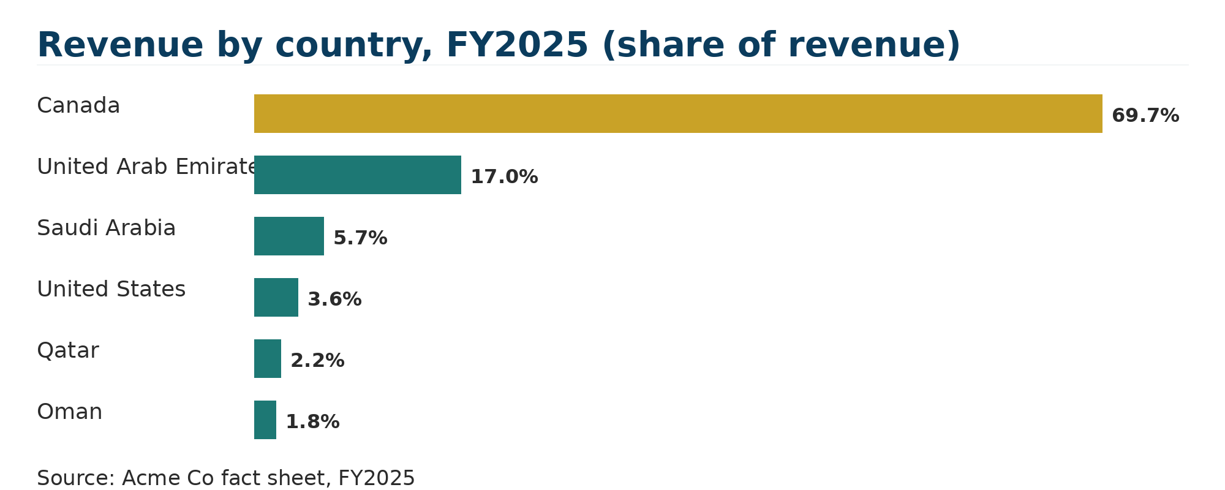
Figure 4 — Revenue by country, FY2025, share of revenue.

5. Risk factors
In the interest of candour, we set out below the concentration risks that an investor should understand about Acme Co. These are the two principal risks of the business, stated plainly, together with one additional consideration.
Category concentration — Material Handling is 56.0% of revenue.
More than half of Acme Co’s revenue comes from a single category. A demand softness, a pricing squeeze, or a shift in how customers source material-handling equipment would flow through to the top line disproportionately. The remaining 44.0% of revenue (computed) is spread across nine other categories, which provides some cushion but does not remove the exposure. Reducing this share over time is a stated FY2026 priority.

Customer concentration — the top 20 customers are 13.65% of revenue.
Our twenty largest customers together represent 13.65% of FY2025 revenue, with the largest relationship at 1.34%. While no single customer is material, the loss of — or a material reduction in purchasing by — a small number of these accounts would be visible in annual results. We manage this through active account review and through the FY2026 plan to broaden the customer base beyond the top 20.

Additional consideration — geographic concentration.
Canada represents 69.7% of revenue and the Gulf region a further 26.7% (computed). A demand, currency, or trade shock concentrated in one of these two regions would therefore affect a meaningful share of the group, even though the customer base itself is diversified.

None of these risks is unusual for a regional distribution business, but each is material enough to shape our operating plan. We monitor category share, top-customer share, and market share at least quarterly, and the FY2026 outlook in the next section is built directly against them.

6. Outlook for FY2026
Looking to FY2026, management is focused on five priorities, each tied to a FY2025 strength or a risk identified above:
1. Protect the 30.0% gross margin. We will hold gross margin at the FY2025 level of 30.0% through sourcing discipline, contract pricing, and mix management, so that the 0.4-point decline of FY2025 does not repeat.
2. Broaden the category portfolio. The objective is to grow Electrical (17.6% of FY2025 revenue) and the mid-tier categories — Packaging, Tools and Safety & PPE — so that the 56.0% Material Handling share moves down over the planning horizon.
3. Deepen the Gulf. The Gulf region contributed 26.7% of FY2025 revenue (computed), led by the United Arab Emirates at 17.0%. We will build on the Dubai platform to grow Saudi Arabia (5.7%), Qatar (2.2%) and Oman (1.8%).
4. Widen the customer base. With the top 20 customers at 13.65% of revenue and no customer above 1.34%, our priority is to add new accounts so that no group of accounts becomes material.
5. Continue to grow orders. After a 4.7% increase to 6,358 orders in FY2025, we intend to sustain order growth while preserving the higher average revenue per order of roughly $10,875 (computed).
In summary: FY2025 delivered 7.9% revenue growth to $69.1 million, gross profit of $20.7 million at a 30.0% margin, and 6,358 orders. FY2026 is about converting that momentum into a broader, more resilient mix — in categories, customers and markets — while defending the margin line. We thank our customers, our suppliers and our shareholders for a solid year.

Forward-looking statement
The outlook section of this report contains forward-looking statements about Acme Co’s priorities. Actual results may differ. All historical figures are taken from the FY2025 fact sheet; figures marked “computed” are arithmetic derived from that fact sheet.

Acme Co · 2200 Industrial Parkway, Toronto, ON M9W 0A1, Canada · Office 1408, Harbour Tower, Dubai, United Arab Emirates

