Annual Report
Fiscal Year 2025

Acme Co — Industrial and office supply distribution
Head office
2200 Industrial Parkway, Toronto, ON M9W 0A1, Canada
Gulf office
Office 1408, Harbour Tower, Dubai, United Arab Emirates
FY2025 at a glance
Measure | FY2025 | FY2024 | Year over year
Revenue | $69.1M | $64.1M | +7.9%
Gross profit | $20.7M | $19.5M | +6.4%
Gross margin | 30.0% | 30.4% | -0.4 points
Orders | 6,358 | 6,071 | +4.7%
All figures as reported in the FY2025 fact sheet. Detail follows in the financial review.
Contents
1. Letter to shareholders
2. FY2025 financial review
3. Category performance
4. Customer and geographic performance
5. Risk factors
6. Outlook for FY2026

Letter to shareholders
Dear shareholders,
Acme Co closed fiscal year 2025 with revenue of $69.1M ($69,146,302.56), an increase of 7.9% over the $64.1M ($64,106,153.02) recorded in fiscal year 2024. Gross profit grew 6.4% to $20.7M, and gross margin was 30.0% against 30.4% in the prior year — a decline of 0.4 points. Orders rose 4.7% to 6,358 from 6,071. The year therefore delivered growth in revenue, gross profit and order volume, with a modest step back in margin.
We distribute industrial and office supplies from a head office at 2200 Industrial Parkway in Toronto and a Gulf office at Office 1408, Harbour Tower in Dubai. That two-hub structure is the backbone of the business: it lets us serve customers across Canada and the United States from Toronto, and across the United Arab Emirates, Saudi Arabia, Qatar and Oman from Dubai. In FY2025 we shipped 6,358 orders across those six countries, and every one was fulfilled from one of those two offices.
The shape of the year is worth describing plainly. Revenue of $69.1M was earned across ten product categories, but the mix is not evenly spread. Material Handling was our largest category at $38,734,228.05, or 56.0% of revenue. Electrical followed at $12,203,595.88, or 17.6%. Packaging ($4,425,870.55, 6.4%), Tools ($3,755,547.27, 5.4%) and Safety & PPE ($2,914,085.72, 4.2%) made up the next tier, with Janitorial ($2,541,723.64, 3.7%), Office Supplies ($1,512,964.36, 2.2%), Abrasives ($1,309,985.75, 1.9%), Fasteners ($1,147,869.20, 1.7%) and Adhesives ($600,432.14, 0.9%) completing the portfolio.
Our customer base remains broad. The twenty largest customers together accounted for 13.65% of FY2025 revenue, and the single largest customer, C0848 Foxglove Stores LLC, accounted for 1.34% of revenue at $926,855.96. No customer in the top twenty exceeded 1.34%. That breadth is a genuine strength, and it is why we describe customer concentration as limited rather than acute.
Geographically, Canada remained our largest market at $48,209,042.23, or 69.7% of revenue, delivered through 4,474 orders. The United Arab Emirates contributed $11,726,342.95, or 17.0%, across 1,069 orders. Saudi Arabia added $3,961,855.28 (5.7%, 401 orders), the United States $2,491,954.15 (3.6%, 178 orders), Qatar $1,504,454.07 (2.2%, 114 orders) and Oman $1,252,653.88 (1.8%, 122 orders).
We want to be candid about what did not go to plan. Gross margin slipped from 30.4% to 30.0%, and gross profit growth of 6.4% trailed revenue growth of 7.9%. Cost of goods sold rose to $48.4M from $44.6M. The margin pressure was modest in absolute terms, but it is the number we are most focused on correcting. We are also conscious that a business earning 56.0% of its revenue from a single category carries a real concentration risk, and we say so directly in the risk factors section of this report.
The monthly pattern of the year was uneven, as it always is in distribution. December was our strongest month at $7,982,078.21 of revenue, closely followed by October at $7,979,546.15 and April at $6,857,863.42. August was the weakest at $3,693,598.05. Managing that rhythm — staffing, stock and freight — without letting service levels slip is the operational discipline the business runs on.
Looking to FY2026, our priorities are straightforward: hold and extend the revenue growth we delivered this year, recover the ground lost on gross margin, broaden the category mix so the business is less dependent on Material Handling, and keep growing the customer base so no single account becomes material to the whole. We will continue to invest behind both the Toronto head office and the Dubai Gulf office, because the two-hub model is what allows us to serve six countries with a single operating approach.
Thank you for your continued support of Acme Co.
The Board and Management of Acme Co
Toronto, Canada

FY2025 financial review
This section sets out Acme Co's reported results for fiscal year 2025 alongside fiscal year 2024. All figures are stated as reported.

Revenue, gross profit and margin
Measure | FY2025 | FY2024
Revenue | $69.1M ($69,146,302.56) | $64.1M ($64,106,153.02)
Cost of goods sold | $48.4M | $44.6M
Gross profit | $20.7M | $19.5M
Gross margin | 30.0% | 30.4%
Orders | 6,358 | 6,071
Table 1 — Reported results, FY2025 and FY2024.
Year-over-year measure | Change
Revenue growth | +7.9%
Gross profit growth | +6.4%
Gross margin change | -0.4 points
Order growth | +4.7%
Table 2 — Year-over-year movements.
Revenue for FY2025 was $69.1M, or $69,146,302.56 to the dollar, compared with prior-year revenue of $64.1M ($64,106,153.02) — revenue growth of 7.9%. Gross profit was $20.7M against $19.5M in FY2024, growth of 6.4%. Gross margin was 30.0% for the year, compared with a prior-year gross margin of 30.4%, a change of -0.4 points.
Because gross profit grew more slowly than revenue, the margin outcome is the central story of the year. Cost of goods sold was $48.4M in FY2025, up from $44.6M in FY2024. The 0.4-point decline is small in percentage terms but meaningful in dollars across a $69.1M revenue base, and it is the measure management is most directly accountable for in FY2026.
Order volume grew 4.7%, from 6,071 orders to 6,358. Revenue growth of 7.9% therefore outpaced order growth of 4.7%, meaning average revenue per order rose year over year. That is a favourable mix signal: the business grew both by serving more orders and by earning more from each one.
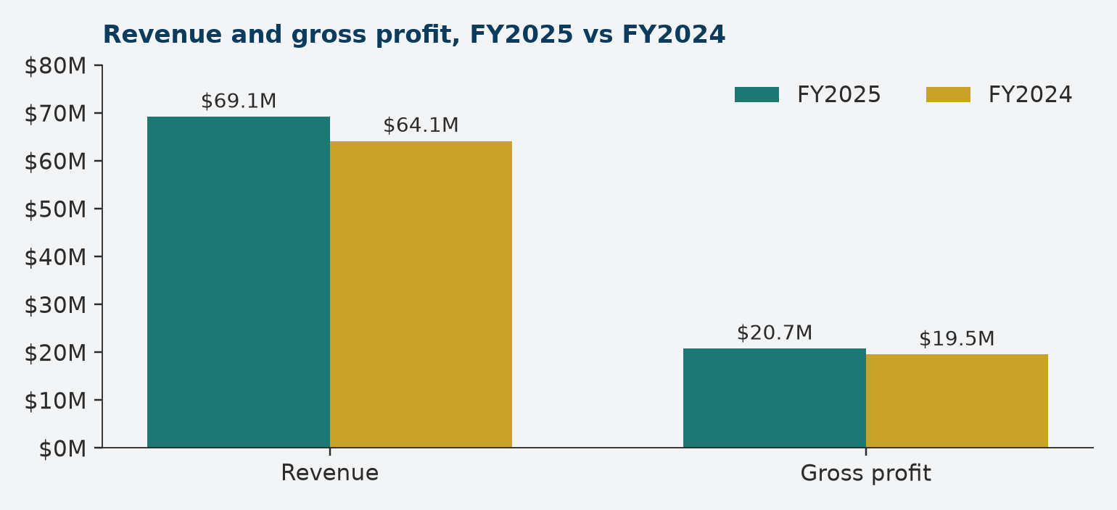
Figure 1 — Revenue and gross profit, FY2025 versus FY2024. Secondary series: FY2025; accent series: FY2024.

Monthly revenue and gross profit
FY2025 revenue was not earned evenly through the year. The table below shows reported revenue and gross profit for each month.
Month (FY2025) | Revenue | Gross profit
January | $5,660,798.91 | $1,697,658.28
February | $4,408,264.69 | $1,419,464.55
March | $5,234,287.17 | $1,596,816.46
April | $6,857,863.42 | $2,045,858.38
May | $4,558,071.52 | $1,472,577.61
June | $4,767,230.19 | $1,520,809.66
July | $4,717,309.03 | $1,392,763.83
August | $3,693,598.05 | $1,119,088.46
September | $6,576,280.41 | $1,916,811.12
October | $7,979,546.15 | $2,379,098.88
November | $6,710,974.81 | $1,945,670.78
December | $7,982,078.21 | $2,226,533.72
Table 3 — Monthly revenue and gross profit, FY2025.
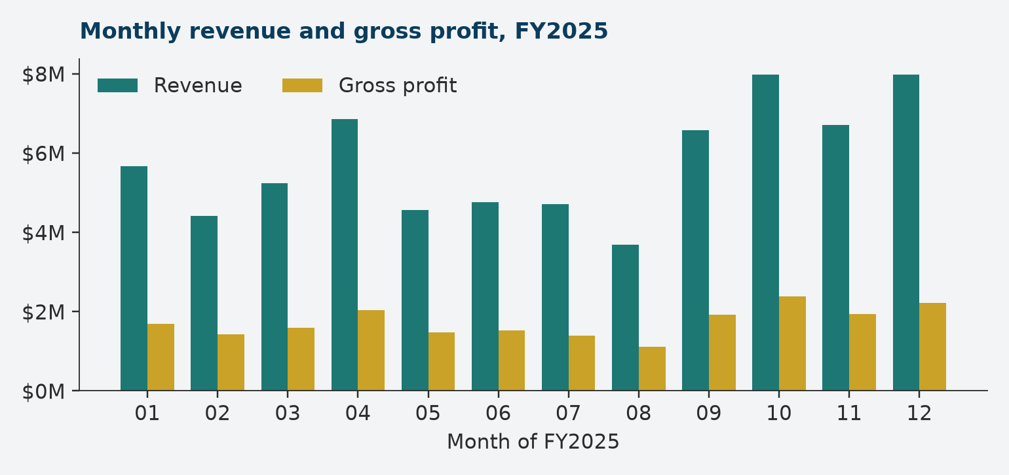
Figure 2 — Monthly revenue and gross profit, FY2025. Secondary series: revenue; accent series: gross profit.
December was the largest revenue month at $7,982,078.21, with October a very close second at $7,979,546.15. April was third at $6,857,863.42, followed by November at $6,710,974.81 and September at $6,576,280.41. At the other end, August was the weakest month at $3,693,598.05, with February ($4,408,264.69) and May ($4,558,071.52) also below the annual run rate.
Gross profit tracked revenue month by month: October contributed the highest gross profit at $2,379,098.88, December $2,226,533.72 and April $2,045,858.38, while August contributed the lowest at $1,119,088.46. The fourth quarter was strong on both lines, consistent with the seasonal pattern of industrial and office supply purchasing as customers close out calendar-year budgets.

Category performance
Acme Co sells across ten product categories. The largest category by a wide margin is Material Handling, which generated $38,734,228.05 in FY2025 — 56.0% of total revenue. The full category mix is set out below.
Category | FY2025 revenue | Share of revenue
Material Handling | $38,734,228.05 | 56.0%
Electrical | $12,203,595.88 | 17.6%
Packaging | $4,425,870.55 | 6.4%
Tools | $3,755,547.27 | 5.4%
Safety & PPE | $2,914,085.72 | 4.2%
Janitorial | $2,541,723.64 | 3.7%
Office Supplies | $1,512,964.36 | 2.2%
Abrasives | $1,309,985.75 | 1.9%
Fasteners | $1,147,869.20 | 1.7%
Adhesives | $600,432.14 | 0.9%
Table 4 — Category mix, FY2025.
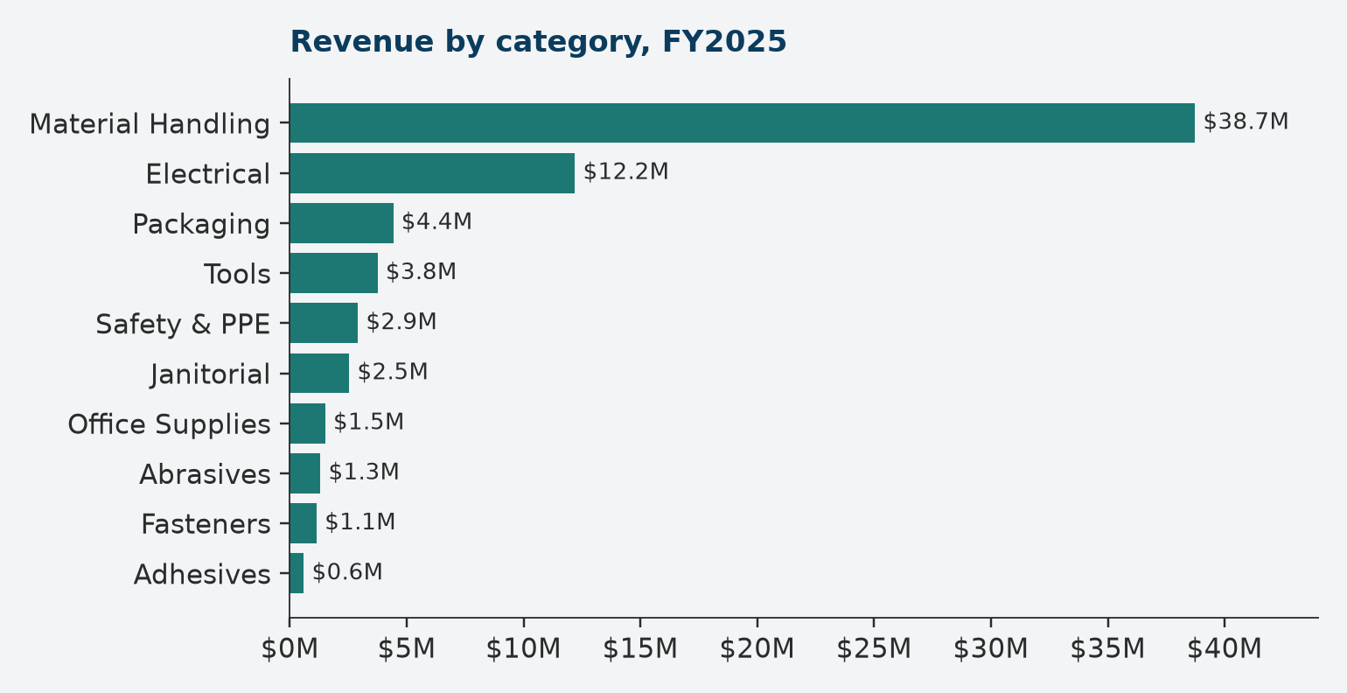
Figure 3 — FY2025 revenue by category.
Material Handling is the anchor of the portfolio. At $38,734,228.05 and 56.0% of revenue, it is more than three times the size of the next category and accounts for the majority of everything Acme Co sells. That is a strength in depth — it is where our sourcing relationships, stock positions and customer familiarity are deepest — but it is also the single largest concentration in the business, and we treat it as such.
Electrical is the second category at $12,203,595.88, or 17.6% of revenue. Together with Material Handling it forms the core of the offer, and it is the category with the clearest adjacency to our existing industrial customer base.
The remaining eight categories are smaller but collectively important to the breadth of the offer. Packaging contributed $4,425,870.55 (6.4% of revenue), Tools $3,755,547.27 (5.4%), Safety & PPE $2,914,085.72 (4.2%), Janitorial $2,541,723.64 (3.7%), Office Supplies $1,512,964.36 (2.2%), Abrasives $1,309,985.75 (1.9%), Fasteners $1,147,869.20 (1.7%) and Adhesives $600,432.14 (0.9%).
These smaller lines matter for a practical reason: they are what make Acme Co a one-stop supplier. A customer buying Material Handling equipment also needs Packaging, Safety & PPE and Janitorial supplies, and filling those needs on the same order is part of why customers stay. They are also the categories with the most headroom to grow, because each starts from a low base relative to Material Handling.
For FY2026 the category agenda is twofold: protect and grow Material Handling, where the bulk of revenue sits, and deliberately build the smaller categories so the revenue mix becomes less dependent on a single line. Progress on the second objective is the most direct way to reduce the concentration risk described later in this report.

Customer and geographic performance

Customer base
Acme Co served 6,358 orders in FY2025 across a broad customer base. The twenty largest customers together accounted for 13.65% of revenue. The single largest customer, C0848 Foxglove Stores LLC, accounted for 1.34% of revenue at $926,855.96. The full top-twenty list is set out below.
Rank | Customer ID | Customer | FY2025 revenue | Share of revenue
1 | C0848 | Foxglove Stores LLC | $926,855.96 | 1.34%
2 | C0029 | Pearl Developments Ltd. | $749,644.27 | 1.08%
3 | C0636 | Granite Fabrication Ltd. | $704,339.72 | 1.02%
4 | C1180 | Montcalm Entreposage inc. | $656,874.93 | 0.95%
5 | C1186 | Falcon Retail Group LLC | $543,431.33 | 0.79%
6 | C0883 | Érable Fleuve Entreposage Inc. | $536,141.25 | 0.78%
7 | C0198 | Saint-Laurent Académie ltée | $504,668.70 | 0.73%
8 | C1985 | Al Waha Property Management LLC | $496,286.01 | 0.72%
9 | C0466 | Driftwood Distribution Ltd. | $461,242.64 | 0.67%
10 | C0717 | Meridian Cedar Developments Ltd. | $433,604.37 | 0.63%
11 | C0402 | Atlas Manufacturing Ltd. | $395,327.98 | 0.57%
12 | C0704 | Meridian Industries Corp. | $368,485.48 | 0.53%
13 | C1683 | Westbrook Logistics LLC | $354,785.74 | 0.51%
14 | C0019 | Fleuve Santé ltée | $344,984.56 | 0.50%
15 | C1156 | Érable Mauricie Collège Inc. | $339,754.87 | 0.49%
16 | C1190 | Fleuve Beauport Logistique inc. | $332,883.86 | 0.48%
17 | C1622 | Bluewater Distribution Ltd. | $331,884.60 | 0.48%
18 | C0685 | Nimbus Distribution Corp. | $322,878.48 | 0.47%
19 | C0092 | Evergreen Trading Ltd. | $319,419.44 | 0.46%
20 | C0419 | Stonebridge Freight Ltd. | $314,446.85 | 0.45%
Table 5 — Top 20 customers, FY2025. Together these customers represent 13.65% of revenue.
The distribution across the top twenty is flat. The largest account is 1.34% of revenue and the twentieth largest is 0.45%. There is no single customer whose loss would materially change the shape of the business, and no cluster of accounts that dominates the book. This is a deliberately diversified customer base, and it is the main reason we describe customer concentration as limited.
The practical implication is that growth has to come from many accounts rather than a few. Winning and retaining a long tail of customers is more labour-intensive than managing a handful of large ones, but it produces a more resilient revenue line, and it is the model Acme Co has built.

Geographic performance
Acme Co operates from Toronto and Dubai and serves six countries. Canada is the largest market by a wide margin; the Gulf markets are served through the Dubai office.
Country | FY2025 revenue | Share of revenue | Orders
Canada | $48,209,042.23 | 69.7% | 4,474
United Arab Emirates | $11,726,342.95 | 17.0% | 1,069
Saudi Arabia | $3,961,855.28 | 5.7% | 401
United States | $2,491,954.15 | 3.6% | 178
Qatar | $1,504,454.07 | 2.2% | 114
Oman | $1,252,653.88 | 1.8% | 122
Table 6 — Revenue and orders by country, FY2025.
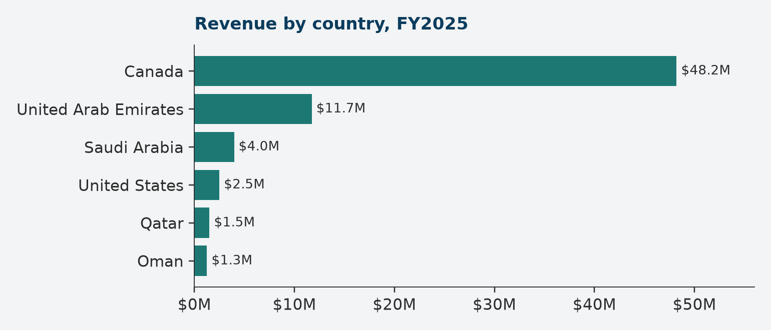
Figure 4 — FY2025 revenue by country.
Canada generated $48,209,042.23, or 69.7% of revenue, across 4,474 orders. The United Arab Emirates was the second market at $11,726,342.95, or 17.0%, across 1,069 orders. Saudi Arabia contributed $3,961,855.28 (5.7%, 401 orders), the United States $2,491,954.15 (3.6%, 178 orders), Qatar $1,504,454.07 (2.2%, 114 orders) and Oman $1,252,653.88 (1.8%, 122 orders).
The geographic profile mirrors the operating footprint. Canada is served from the Toronto head office and accounts for the majority of revenue and order volume. The four Gulf markets — the UAE, Saudi Arabia, Qatar and Oman — are served from the Dubai Gulf office and together form the international growth platform. The United States is served alongside Canada from Toronto.
Two features deserve emphasis. First, Canada at 69.7% of revenue is a genuine concentration: conditions in the Canadian market will continue to drive the majority of our results. Second, the Gulf markets are diversified within themselves — the UAE is the largest at 17.0%, while Saudi Arabia, Qatar and Oman each contribute between 1.8% and 5.7%, so no single Gulf market dominates the international book.

Risk factors
The risks below are the ones that matter most to an investor reading this report. We state the concentration risks plainly and without softening, because they are structural features of the business rather than temporary conditions.

Category concentration — Material Handling
Material Handling accounted for $38,734,228.05, or 56.0% of FY2025 revenue. This is the single largest concentration in the business: more than half of everything Acme Co earns comes from one category.
The consequence is direct. Demand conditions, pricing, competitive intensity or supply disruption in Material Handling will affect the majority of our revenue, and a decline in that category could not be offset by growth in the smaller categories at their current scale. Material Handling is also where our largest stock positions and supplier relationships sit, so disruption there carries operational as well as commercial risk.
Mitigation is a matter of mix rather than retreat. We intend to keep investing in Material Handling because it is the core of the offer, while deliberately growing Electrical, Packaging, Tools, Safety & PPE and the other categories so the share of revenue from any single line falls over time.

Customer concentration
The twenty largest customers accounted for 13.65% of FY2025 revenue. The largest single customer, C0848 Foxglove Stores LLC, accounted for 1.34% of revenue at $926,855.96.
We state this plainly because it cuts both ways. Customer concentration is limited: no customer exceeds 1.34% of revenue, and the top twenty together are 13.65%, so the loss of any single account would be painful but not destabilising. The corresponding risk is that revenue is spread across a long tail of accounts, so growth depends on winning and retaining many customers rather than a few, and administrative and service costs are spread across a larger customer population. A broad base can also mask gradual attrition, so we track the top twenty accounts closely and treat the 13.65% figure as a measure to be monitored rather than a comfort.

Geographic concentration
Canada generated 69.7% of FY2025 revenue, or $48,209,042.23 across 4,474 orders.
The majority of the business depends on one national market and on one office — the Toronto head office. Canadian economic conditions, freight costs, labour availability and currency movements therefore affect most of our results. The Dubai Gulf office provides diversification across the UAE (17.0% of revenue), Saudi Arabia (5.7%), Qatar (2.2%) and Oman (1.8%), but those markets together remain a minority of revenue.

Margin and cost risk
Gross margin declined 0.4 points, from 30.4% in FY2024 to 30.0% in FY2025, while cost of goods sold rose from $44.6M to $48.4M.
Gross profit growth of 6.4% trailed revenue growth of 7.9%. If input costs continue to rise faster than we can recover them in pricing, margin will compress further, and because revenue is concentrated in Material Handling, cost movements in that category have an outsized effect on group margin. Protecting margin is therefore a FY2026 priority rather than a background concern.

Operational and market risk
Acme Co fulfils 6,358 orders a year from two offices serving six countries. That model depends on reliable freight, accurate stock positions and functioning cross-border processes. A disruption at either office, or in the freight lanes between them and our customers, would affect order fulfilment directly. Competition in industrial and office supply distribution is a standing risk too: customers can source many of the products we sell from alternative suppliers, so service quality and availability are what retain them.
Seasonality is a further consideration. FY2025 revenue ranged from $3,693,598.05 in August to $7,982,078.21 in December, so planning, staffing and working capital have to absorb a wide monthly swing. Poor planning against that pattern would show up as either excess stock or missed orders.

Outlook for FY2026
Acme Co enters FY2026 with revenue of $69.1M, gross profit of $20.7M, a gross margin of 30.0% and 6,358 orders behind it. The year just closed delivered growth on revenue (+7.9%), gross profit (+6.4%) and orders (+4.7%), with a 0.4-point decline in gross margin. Our FY2026 agenda builds directly on that position.

Grow revenue and orders
Revenue growth of 7.9% and order growth of 4.7% in FY2025 came from a customer base in which the top twenty accounts represent 13.65% of revenue. Growth in FY2026 will therefore continue to come from breadth: adding customers, deepening existing relationships and extending the categories each customer buys. The two-hub structure — Toronto for Canada and the United States, Dubai for the UAE, Saudi Arabia, Qatar and Oman — is the platform for that work, and both offices will be supported to grow.

Recover gross margin
Gross margin moved from 30.4% to 30.0% in FY2025, a change of -0.4 points, and gross profit growth of 6.4% lagged revenue growth of 7.9%. Recovering that ground is the clearest single improvement available to the business. The work is commercial rather than structural: pricing discipline, category-level margin management and attention to cost of goods sold, which stood at $48.4M in FY2025 against $44.6M in FY2024.

Broaden the category mix
Material Handling at 56.0% of revenue is the concentration we most want to reduce. FY2026 priorities are to hold and grow Material Handling while deliberately building Electrical (17.6% of FY2025 revenue), Packaging (6.4%), Tools (5.4%) and Safety & PPE (4.2%), and to develop the smaller lines — Janitorial (3.7%), Office Supplies (2.2%), Abrasives (1.9%), Fasteners (1.7%) and Adhesives (0.9%) — where the base is lowest and the headroom greatest. Success here reduces risk as well as adding revenue.

Keep the customer base broad
The top twenty customers represent 13.65% of revenue and the largest single customer 1.34%. That is a healthy position and we intend to keep it that way. FY2026 will see continued focus on winning new accounts and retaining the long tail, so that growth does not come at the cost of dependence on a small number of customers.

Operate the two-hub model well
With 6,358 orders fulfilled in FY2025 from Toronto and Dubai across six countries, execution is where the plan is won or lost. Priorities for FY2026 are stock availability in the categories that carry the most revenue, reliable cross-border freight, and planning that absorbs the monthly swing in demand — from the $3,693,598.05 low of August to the $7,982,078.21 high of December.

What we will not do
We will not chase revenue at the expense of margin, and we will not allow the business to become more dependent on a single category or a single customer in pursuit of short-term growth. The FY2025 results show what the model can deliver: 7.9% revenue growth on a broad customer base across six countries. FY2026 is about delivering that again, with a better margin outcome and a more balanced mix.

This report contains only the figures set out in the FY2025 fact sheet. Acme Co is a fictional company; the offices, customers and results described here are illustrative.

